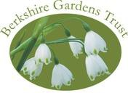BERKSHIRE GARDENS TRUST

EARLY AUTUMN VISIT

Tuesday 15th September 2026, 2.00pm to 4.00pm

GUIDED TOUR OF ROYAL HOLLOWAY COLLEGE, EGHAM, SURREY

We are very pleased to invite you to join us on a private visit to Royal Holloway College in Egham, Surrey. Our tour will be guided by Daniel Steel, Senior Gardener at the college. Dan has over 10 years’ experience in arboriculture and the management of historic landscapes having trained at Westonbirt Arboretum and previously worked for the Crown Estate at Windsor Great Park. He has spent his career to date conserving the natural and cultural heritage of historic landscapes.

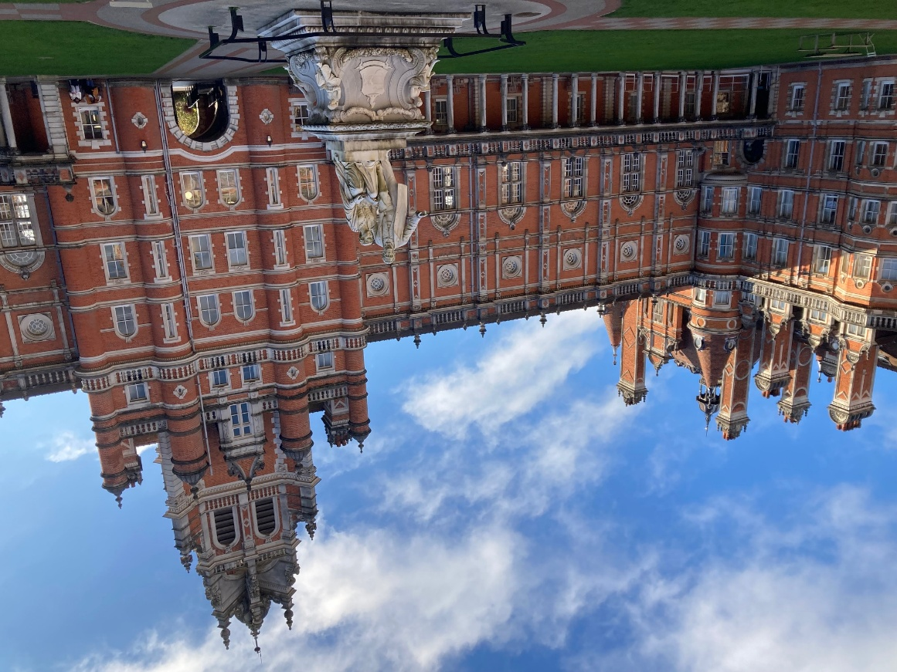

The story of Royal Holloway College, which is now part of the University of London, began 140 years ago when it was opened by Queen Victoria in 1886. Its founders were Elizabeth Jesser Reid and Thomas and Jane Holloway, Victorian social pioneers who wanted to make a difference and established the college as one of the first places in Britain where women could access higher education.
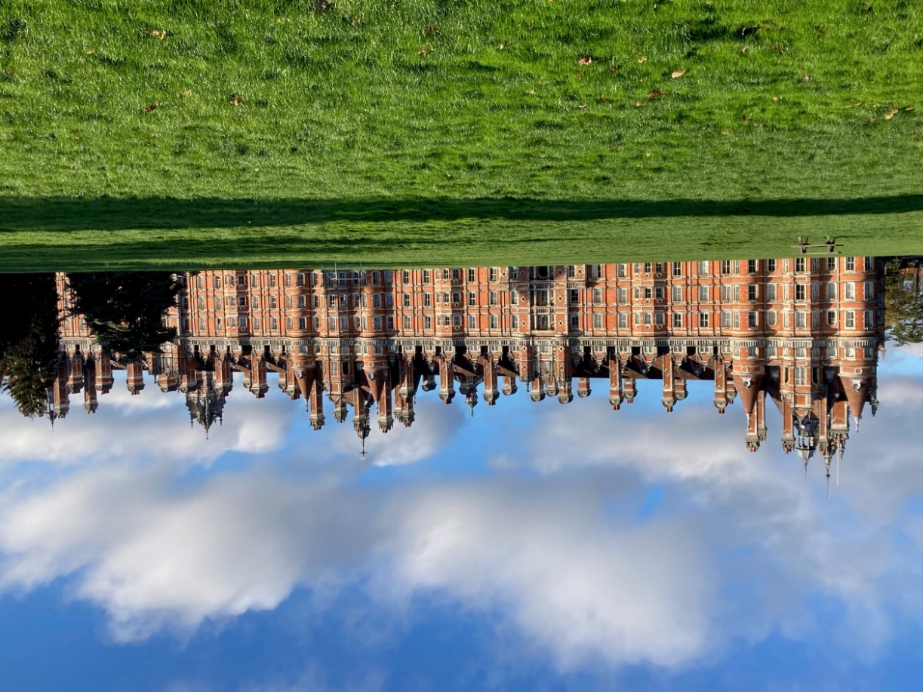

Royal Holloway University sits within 135 acres of beautiful parkland. The historic buildings, including the stunning Grade 1 listed Founders Building, are surrounded by formal designed gardens mainly comprising shrubs and some large, ancient parkland trees. We will also visit the wider campus which includes less formal areas such as wildflower meadows, ponds and woodland which Dan and his team are managing for both their amenity value and the wildlife. There may also be the opportunity to visit the Picture Gallery, the Chapel and the Grade II listed Victorian swimming pool.

Refreshments will be available to purchase at the cafés at the college both before and after the tour as desired.

Accessibility:
Car parking is available but we encourage you to car share if you can. Details will be sent in the Joining Instructions a week beforehand to those attending.

Bookings: For this special event, booking is preferably via our website through Ticketsource or by sending a booking form and cheque to Kim Hacker, Woodcroft South, Garth Close, Winnersh, RG41 5LY (see below). Please book before Friday 4th September to avoid disappointment.

Access to Gardens: There is uneven ground and several steps throughout the grounds although much is level or gently undulating with smooth surfaces. Some parts of the tour will be on mown meadow paths where conditions may be a little muddy if there’s been recent rain. Please let us know at the time of booking if you will need assistance.
Queries: Please contact Kim by email at berksgtmembership@gmail.com, or phone her on 07752 190391 or Michelle Leek on 07886 000824 for queries about the visit.

Booking:

Tickets are £12 for members and £15 for non-members.

There are three ways to book:
1. To book ONLINE, please visit our website at www.berkshiregardenstrust.org and click on ‘2026 Events’ or
2. Go direct to Ticketsource at https://ticketsource.co.uk/berkshire-gardens-trust or
3. If not booking direct or through Ticketsource, please first send an email to Kim Hacker at BerksGTenquiries@gmail.com to confirm that there is space available. Then once you receive a confirmation email, please send the booking slip below to the Membership Secretary, Berkshire Gardens Trust, Woodcroft South, Garth Close, Winnersh, RG41 5LY, and select payment method by Friday 4th September. Confirmation of booking will be sent by email.

Payment by BACS can be made as follows:
Account name: Berkshire Gardens Trust
Sort code: 30-54-66
Account No.: 10263868

Please include your name & event as reference, e.g., Smith Royal Holloway.

Payment by cheque (send to Kim Hacker) to be made payable to Berkshire Gardens Trust.

Kim will send out joining instructions by email in the week before the event.

BERKSHIRE GARDENS TRUST’S EARLY AUTUMN VISIT TO ROYAL HOLLOWAY COLLEGE 2.00PM, 15 SEPTEMBER 2026

Name(s) (please print): ...................................................................................................
Email: ………………………………………………….…

I would like the following tickets:
...........member tickets at £12 each
.......... non-member tickets at £15 each.

Please provide a cheque made payable to Berkshire Gardens Trust. Confirmation of bookings will be sent by email.

