BERKSHIRE GARDENS TRUST FORTHCOMING EVENTS PROGRAMME 2026

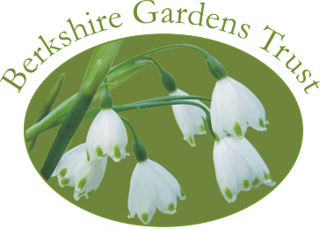

DETAILS FOR ALL EVENTS WILL BE SENT OUT TO ALL MEMBERS AND APPEAR ON OUR WEBSITE WITH A LINK TO BOOK VIA TicketSource OR CLICK ON:
https://www.ticketsource.co.uk/berkshire-gardens-trust

SUMMER PROGRAMME

THURSDAY 27TH AUGUST 2PM: VISIT TO WATERPERRY GARDENS
Inspired by Ursula Buchan’s talk on Valerie Finnis in 2025 we will enjoy a guided visit to Waterperry with Rob Jones, Head Gardener.
£23 members / £26 non-members (including entrance).

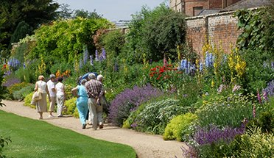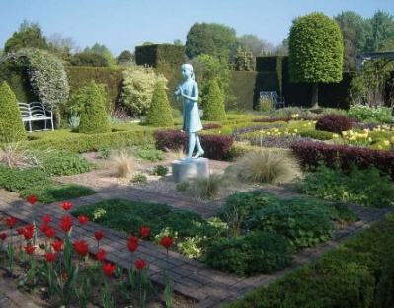
Waterperry Gardens have been a source of inspiration and a gardener's delight for more than eighty years. Many of us have been to Waterperry but we will have an opportunity to hear about the wonderful progress made at the gardens in recent years and the splendour of the late summer/autumn plantings. Refreshments will be available to purchase at the café on site.

AUTUMN AND WINTER PROGRAMME

TUESDAY 15TH SEPTEMBER 2PM: VISIT TO ROYAL HOLLOWAY COLLEGE
Following Daniel Steel’s excellent presentation in October 2024, we will enjoy a visit to the gardens guided by Daniel, conservationist, garden history and landscape manager, master arborist, and horticulturist.
£12 members / £15 non-members.

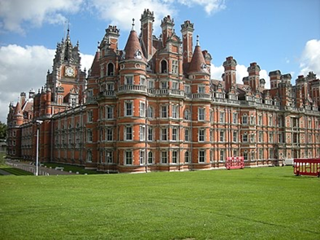
Royal Holloway University sits within 135 acres of beautiful parkland. The 130 year old historic buildings, including the stunning Founders Building, are surrounded by formal designed gardens mainly comprising shrubs and some large, ancient parkland trees. We will also visit the wider campus which includes less formal areas such as wildflower meadows, ponds and woodland which Dan and his team are managing for both their amenity value and the wildlife. Refreshments will be available to purchase at the cafés at the college.

WEDNESDAY 7TH OCTOBER 10.30am: MORNING AGM AND VISIT TO ENGLEFIELD GARDENS
We are delighted to be able to combine our AGM with a special guided visit to the gardens of Englefield House by kind permission of Lord and Lady Benyon. £18 Members and £20 non-members.
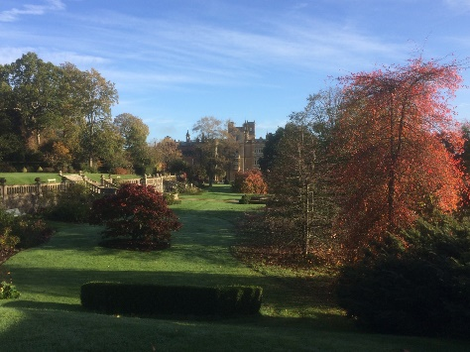
The gardens at Englefield look particularly attractive when the plants turn to their autumn colours. They are particularly famous for the three distinct, multi-level terraces, sweeping woodland walks and a restored walled kitchen garden.

The morning, starting at Englefield Village Hall, will include coffee and cake, with a short AGM, from where we will start the guided tour. There will be the chance to walk up to the gardens (or lifts will be available). We will take a look at the recent tree that King Charles III planted earlier this year. We will also be able to admire the magnificence of Englefield House, largely rebuilt in the 1850s, overlooking a historic deer park. We may even identify scenes from several films and series recently filmed here.

We look forward to welcoming many members and non-members on this visit.

TUESDAY 10TH NOVEMBER 7PM: ZOOM TALK
Landscape historian Sarah Rutherford will give an illustrated talk on the history of grottos including Ascot Place, Berkshire. £7 members and non-members.
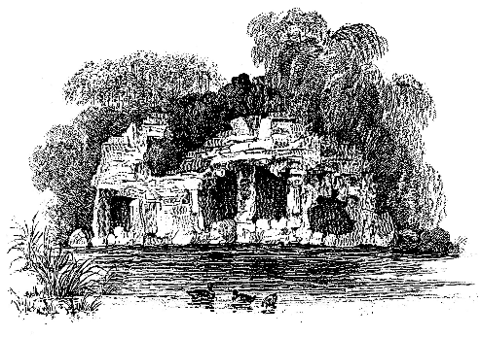
Sarah is currently writing a book on Grottos in the UK to be published later this year. She has extensive experience as an author and researcher which she will bring to her illustrated talk. She will focus on the extraordinary grotto at Virginia Water, and that at Ascot Place, a private Grade II* Registered Park and garden. Zoom talks will be recorded unless otherwise stated.

WE LOOK FORWARD TO SEEING YOU AT THE ABOVE EVENTS.

