

BERKSHIRE GARDENS TRUST

SUMMER GARDEN VISIT

2.30 pm Thursday 27th August 2026

GUIDED TOUR OF THE DELIGHTFUL GARDENS AT WATERPERRY, WATERPERRY, OXFORD OX33 1JZ

We are pleased to be able to invite you to join us on Thursday 27th August for a guided garden tour of Waterperry Gardens given by Rob Jacobs, the Horticultural Manager. We will be in very knowledgeable hands with Rob giving us all his expertise on the development of the gardens over his time at Waterperry.

Robert started work as an apprentice at Waterperry in 1979. After working in all departments, he decided to specialise in herbaceous and alpine plants, becoming Horticultural Manager in 1993.

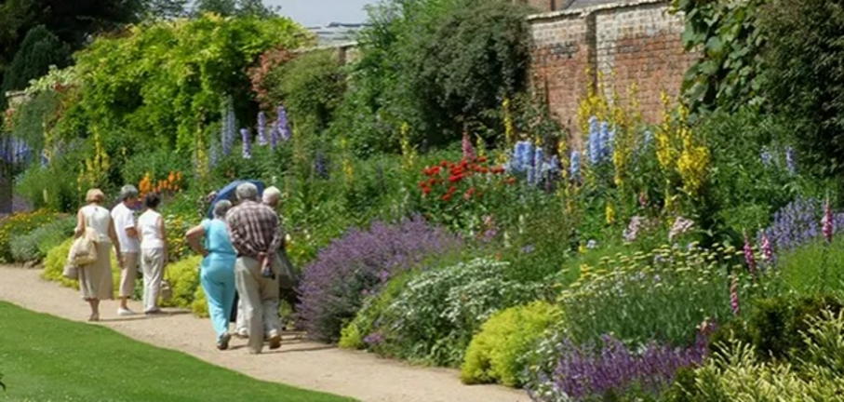 | Susie Hunt, a broadcaster and contributor to Country Gardener, wrote of Waterperry “There are some gardens that exude a special something. It’s impossible to put your finger on exactly what it is – or even to give it a name; it’s more a case of feeling as though you can breathe again, of finding an inner peace.”

Waterperry Gardens are the heritage of the horticultural school, run by Beatrix Havergal with her partner Avice Sanders, for women, between 1932 and 1971, when the emphasis was on food production rather than spectacular ornamental gardens. They won numerous medals at Chelsea. Our recent zoom talk on Valerie Finnis, a student here in the 40s, may have wetted your appetite to visit for the first time or to revisit.

Over the past twenty years the gardens have developed and grown, and many new projects have been undertaken and completed. There is now a Formal Garden, the Mary Rose Garden, a Waterlily Canal and the Long Colour (Herbaceous) Border. There is also an arboretum in the meadow area beyond the canal.

In July through to September, the herbaceous border is in full glory, with the tall Delphiniums in full show, and later the September Asters are at their peak, and this is also Michaelmas Daisy season, and the changing colour scheme continues with a change towards varieties of green. Our August visit will be perfect for this full glory.  Notable plants here are Callicarpa ‘Profusion’, a collection of Buddleia davidii and Sambucus ‘Black Beauty’. In the silver leaf area, you can see Atriplex halimus, Cardoons and Salix argentea. In season Dahlias such as ‘Bloodstone’, ‘Lilactime’ and ‘Bishop of Llandaff’ and bedding plants Verbena ‘La France’, Tagetes ‘Jolly Jester’ and Rudbeckias add to the riot of colour in these 100m long double borders. | 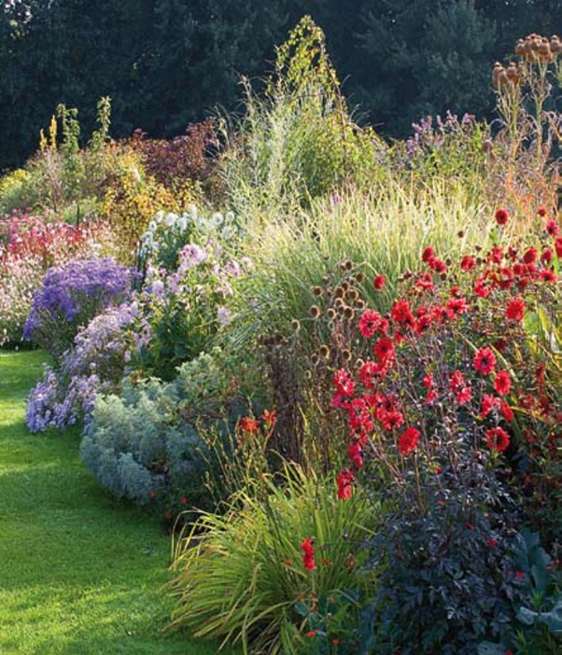

There is so much to see at Waterperry. The site includes a Garden Shop, Plant Centre, Gift Barn, Art in Action Gallery, Rural Life Museum, Saxon Church, and there is a super teashop offering homemade hot and cold meals, pastries and cakes. Maybe you might like to get some lunch there before the tour begins? The current art exhibition which will be on display– A brighter view – Colours in the landscape - features four Oxfordshire artists who all specialize in modern, colourful depictions of landscapes.

Accessibility:
Car parking is available at the gardens. Details will be sent in Joining Instructions a week beforehand to those coming to the event.

Access to Gardens: The entire garden is more or less on the level and most areas are accessible by paths. Please let us know at the time of booking if you will need help.

Queries: Please contact Kim by email at berksgtmembership@gmail.com ,
or phone her on 07752 190391
or Susan Carter on 07711 420586 for queries about the visit.

Booking:

Tickets are £23 for members and £26 for non-members.

Unfortunately, we have to limit numbers to 30 people.

There are three ways to book:
1. To book ONLINE, please visit our website at www.berkshiregardenstrust.org and click on “2026 Events” or
2. Go direct to https://www.ticketsource.co.uk/berkshire-gardens-trust or;
3. If not booking as above, please first send an email to Kim Hacker at BerksGTenquiries@gmail.com to confirm that there is space available. Once you receive a confirmation email, please send the booking slip below to the Membership Secretary, Berkshire Gardens Trust, Woodcroft South, Garth Close, Winnersh, RG41 5LY and select payment method. Confirmation of bookings will be sent by email.
• Payment by BACS;
▪ Berkshire Gardens Trust
▪ Sort code: 30-54-66
▪ Account no: 10263868
▪ Reference: your name and event (eg Smith Waterperry)
• Cheque (sent to Kim Hacker). Cheques to be made payable to Berkshire Gardens Trust.

Kim will send out joining instructions by email in the week before the event.

All pictures courtesy of Waterperry

……………………………………………………………………………………………………

BERKSHIRE GARDENS TRUST SUMMER GARDEN VISIT TO WATERPERRY
2.30 pm Thursday 27th August 2026
Name(s) (please print): ...................................................................................................
Email: ………………………………………………….…

I would like the following tickets:
...........member tickets at £23 each
.......... non-member tickets at £26 each.

Please provide a cheque made payable to Berkshire Gardens Trust. Confirmation of bookings will be sent by email.

